## Module 11 Student Questions

## Observation Experiment - Individual Reflection

1. Do these results support the wave-like nature of light?
2. Do these results support the particle-like nature of light?
3. What can these experimental results tell us about the quantum nature of light?

## Observation Experiment - Small Group Discussion

1. What aspects of quantum superposition have you seen in the study of NMR already?
2. Is the quantum behavior of spins necessary for understanding and analyzing NMR data?
3. We have seen that interactions with the environment can cause the relaxation of quantum spins so that they are no longer in a superposition state. Provide a possible explanation of why we do *not* observe objects in a state of superposition outside of the quantum realm.

## Relating the Postulates of Quantum Mechanics to NMR - Guided Inquiry Questions

1. Do the spin-1/2 state vectors represented on the Bloch sphere reside in a real or complex vector space? Explain your reasoning.

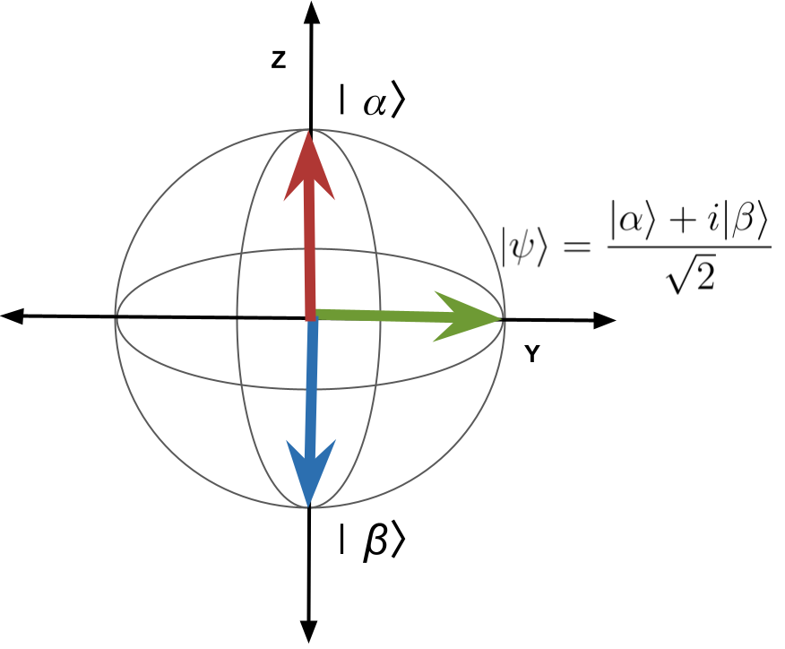

1. Consider the three spin-1/2 quantum states shown in the Bloch sphere above. Which states would be considered stationary states? Explain your reasoning.
2. What observables are associated with the stationary states you identified in the previous question?
3. If you wait a long time, what state would you predict the spin-1/2 particle to be in? Explain.
4. If you apply a 180-degree pulse to a spin initially in |α⟩, what state would you predict the spin to be in after the pulse?
5. Provide a pulse sequence you could use to put a spin initially in |α⟩ into a superposition state like |Ψ⟩ in the Bloch sphere above.

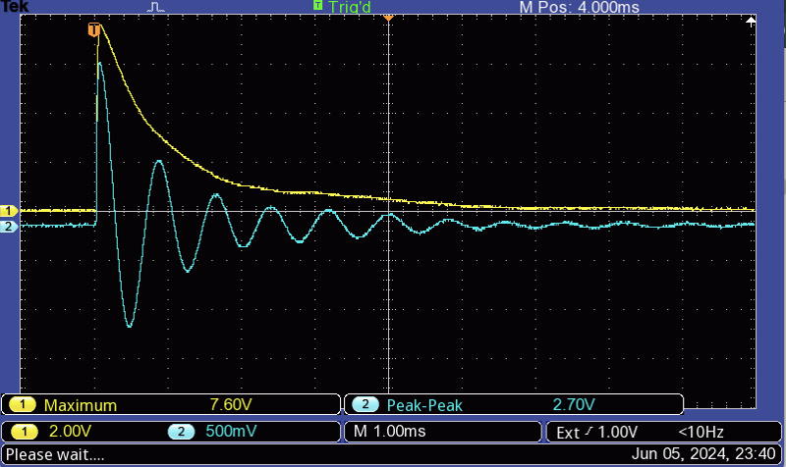

1. The figure above shows the result of a free induction decay (FID) experiment of protons in a sample of mineral oil. Is this an example of decoherence? Why or why not?
2. How does the time-varying nature of a precessing quantum spin suggest that the spin is *not* in a stationary state, but instead in a superposition state? Does this agree with which states we know will and will not precess in the Bloch sphere representation?
3. Physicists use multiple-pulse sequences like the Hahn echo or CPMG to “increase the coherence time”. What do you think they mean by that? Why might that be useful?

## Heisenberg Uncertainty Principle - Guided Inquiry Question

1. Stationary states are not time-varying, so we know that the quantum system will stay in those states until acted upon (Δt→very large). What does the energy-time uncertainty principle then tell us about our uncertainty in the energy of a stationary state?

## Testing Experiment - Guided Inquiry Questions

1. Thinking about the dynamics of spins along the Bloch sphere using the [Bloch simulator](https://www.drcmr.dk/BlochSimulator/), do you expect the MR signal amplitude to be different if you use a 450-degree pulse instead of a 90-degree pulse? Explain your reasoning.
2. The Bloch simulator pulses assume the pulses are sent at the Larmor frequency of the spins (often called “on-resonance”). But now we will be deliberately driving the spins “off-resonance” to see the resonance curve. Using the energy-time uncertainty principle, do you expect the width of the resonance peak (directly proportional to Δf) to increase or decrease when you use the 450-degree pulse instead of the 90-degree pulse?

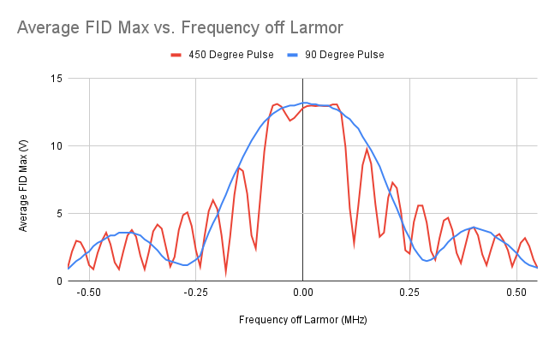

1. Check out the results of the experiment [here](https://docs.google.com/document/d/1RHVnelv7SdAmcSVdDilSEx9RDyXgZM09aj864OBsb1o/edit?usp=sharing) or view the frequency-domain curves above. Does this agree with the energy-time uncertainty principle?

## Reflection Questions

1. Provide three examples of how elements of NMR we have studied directly connect to important postulates of quantum mechanics.
2. Write a short response in agreement or disagreement to the following statement: “The fact that quantum mechanics is probabilistic and the predictions inherently uncertain means that it is an inferior theory to classical mechanics where predictions are deterministic and exact.”
3. NMR is one application of quantum theory that has made an important scientific impact. Check out other technologies that have come out of our understanding of quantum mechanics [here](https://www.forbes.com/sites/chadorzel/2015/08/13/what-has-quantum-mechanics-ever-done-for-us/). Pick one of these technologies and briefly describe its scientific and/or cultural impact.

### Follow this rubric to assess your work for this module:

|  |  |  |  |  |
| --- | --- | --- | --- | --- |
| **Learning Outcome** | **Adequate** | **Needs improvement** | **Inadequate** | **Missing** |
| **Is able to connect important postulates of quantum mechanics to what we know about NMR** | Can provide NMR examples for all four postulates of quantum mechanics introduced in the module. | Can provide NMR examples for most of the four postulates of quantum mechanics introduced in the module. | Struggles to provide NMR examples for most of the four postulates of quantum mechanics introduced in the module. | Cannot provide NMR examples for any of the four postulates of quantum mechanics introduced in the module. |
| **Is able to interpret NMR experiments using quantum mechanics terminology** | Can easily use quantum mechanics terminology correctly to explain NMR experiments. | Can utilize most of the quantum mechanics terminology correctly to explain NMR experiments. | Struggles to use the quantum mechanics terminology correctly to explain NMR experiments. | Does not attempt to use quantum mechanics terminology to explain NMR experiments. |
| **Is able to predict how the resonance lineshape changes with longer pulses using the uncertainty principle** | Can accurately predict how the resonance lineshape changes with longer pulses using the uncertainty principle. | Makes a prediction of how the resonance lineshape changes with longer pulses, but the prediction has some errors or doesn’t correctly use the uncertainty principle. | Makes a prediction of how the resonance lineshape changes with longer pulses, but does not use the uncertainty principle in making this prediction. | Does not attempt to make a prediction of how the resonance lineshape changes with longer pulses. |